**Door Kickers Game Research**

Steam Link: <http://store.steampowered.com/app/248610/Door_Kickers/>

**Synopsis**

Door kickers is a top down real-time strategy game involving fast paced levels that usually last under a minute to execute, but much longer to plan out. The player controls a SWAT team commander and issues commands to each of their SWAT units to eliminate any enemy threats in a level. They have an arsenal of equipment available to them that expands with game progression to help dispatch the enemies.

**Relation to our brief**

Our brief focusses on the aspect of having multiple solution to complete a goal rather than a single solution as found in a lot of puzzle games. In door kickers players are given a set goal for each level, however this goal can be met in a huge number of ways depending on how the player sets up their squad and carries out actions. This allows for perfectionists to strive to complete a level as fast as possible without taking any hits from enemies or for more casual players to play out the level in their own way. It also serves as a good basis for sharing levels with other users because of the vast amount of ways to complete each level. I believe this leads to a slightly out of the box way of tackling the brief, as most people would instantly think about a typical puzzle game; which Door Kickers is most definitely not.

**Core Game Loop**

* Assign SWAT members with suited roles to your squad
* Assign chosen equipment to members
* Set up starting positions for squad members
* Set up paths for squad members to take
* Add actions on opening doors
* Add flashbangs etc.
* Start scenario
* Pause if unexpected AI behaviour is encountered
* Readjust strategy
* Repeat and iterate strategy until all enemies are defeated and some members of squad still live
* Move on to next level once satisfied with score

**Game Mechanics**

* Equipping squad members with equipment and setting starting positions
* Adjusting paths for squad members to take
* Timing door entries with other squad members/flashbangs
* Placing flashbangs tactically
* Using snipers when needed
* Resource management of health, armour and ammo.

**Player Challenges**

* The AI in Door Kickers is heavily based on emergent behaviour. It is very hard to predict where enemies will be, and their starting positions aren’t always the same each time you reset the level. The player must be ready to anticipate many different situations to clear levels without squad casualties.
* You have a limited number of flashbangs and other devices to use, and during later levels it becomes important to use these with care and no wastefully.
* It is easy to focus on part of your squad and forget about the other squad members whilst they are moving to a location. They may come across enemies you weren’t expecting and if left for even a few seconds without attention, you can fail the mission. It is important to be ready to pause the game change your strategy to combat unseen circumstances.
* Having the right squad members with specific roles can help hugely during later missions. There is an element of synergy that if used well can help enormously.

**Screenshots**

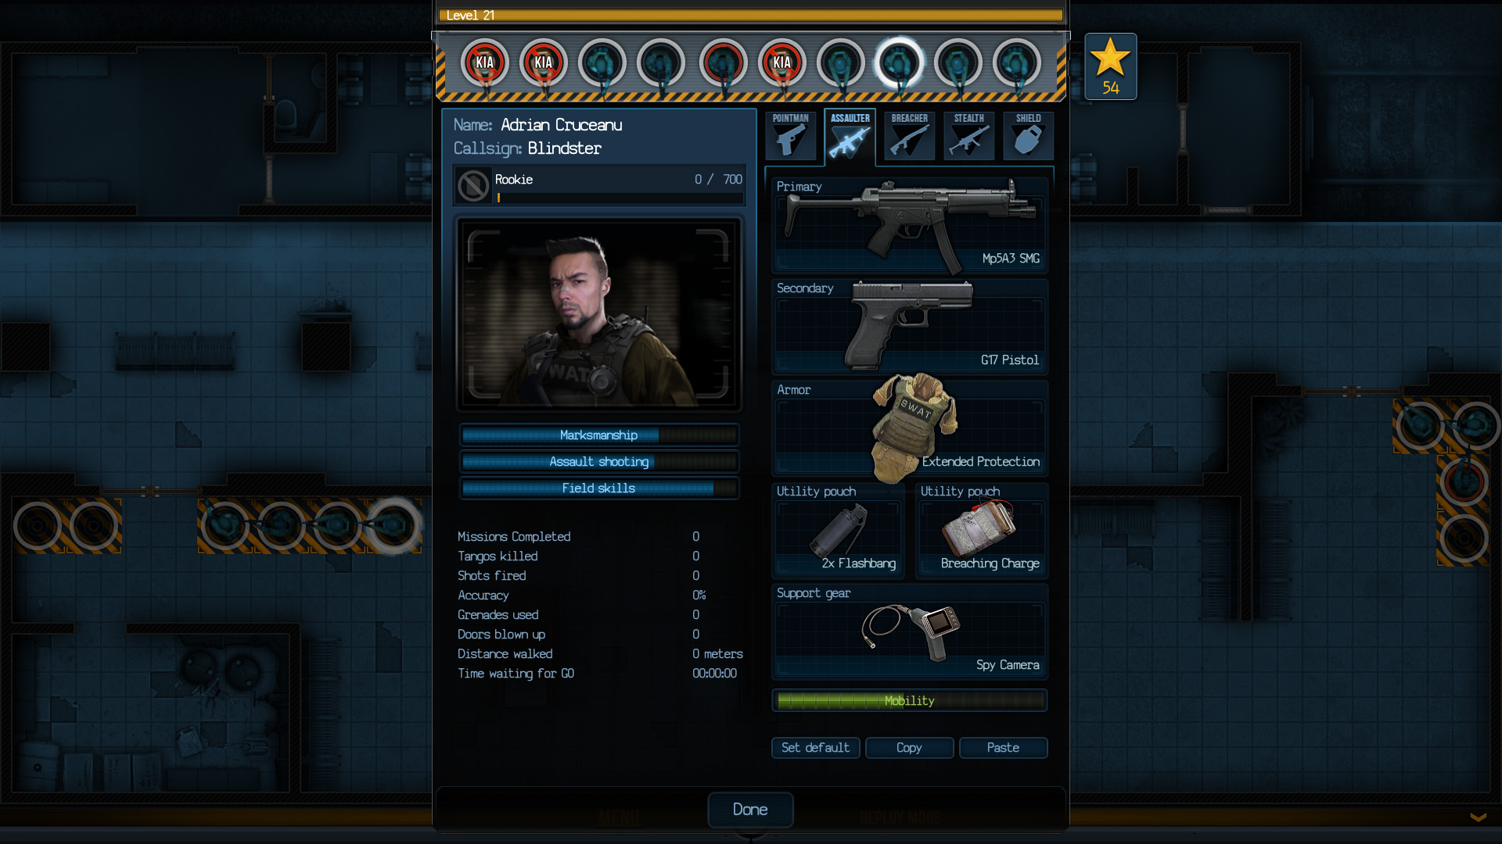

Figure 1 Squad member customisation screen (This character is an Assaulter)

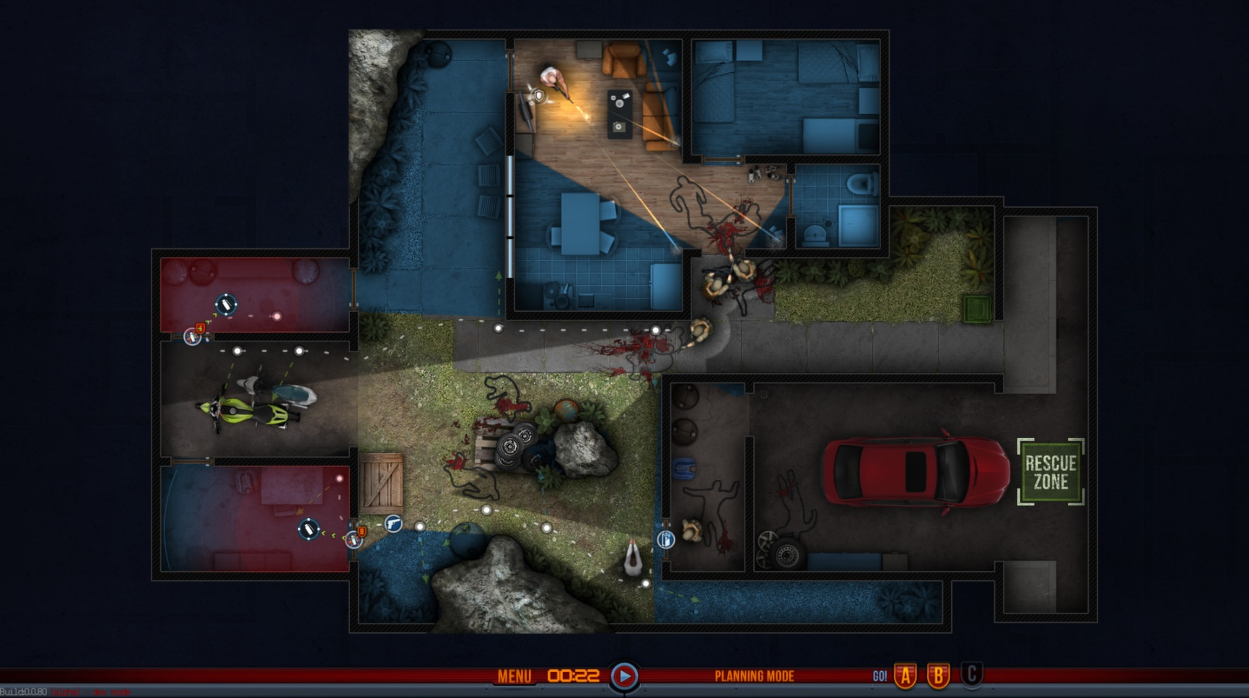

Figure 2 Planning squad routes

All images are referenced from the official steam store page for Door Kickers:

<http://store.steampowered.com/app/248610/Door_Kickers/>